PC Assemble
a. Summary of What I Gained from the PC Assembly
From the PC assembly session, I gained valuable hands-on experience in identifying and assembling computer hardware components such as the motherboard, CPU, RAM, power supply, storage devices, and cables. This activity helped me better understand the function of each component and how they work together to form a complete computer system.
In addition, I learned the correct procedures and safety precautions during hardware installation, such as proper cable management and careful handling of sensitive components. Overall, the PC assembly enhanced my practical knowledge and strengthened my understanding of computer system architecture, which complements the theoretical concepts learned in class.

b. Suggestions for Improvement
One improvement that could be made is to allocate more time for the PC assembly session. With additional time, students would be able to explore each component in greater detail and gain more confidence during the assembly process. Furthermore, providing a step-by-step guide or short demonstration video before the session would help students better prepare and reduce confusion during the activity. Increasing the number of instructors or assistants during the session could also help students who require immediate guidance.

c. Additional Reflection
In my opinion, the PC assembly session was an engaging and effective learning activity that encouraged teamwork and problem-solving skills. This activity also increased my interest in computer hardware and inspired me to learn more about system maintenance and troubleshooting. Such practical sessions are important because they bridge the gap between theory and real-world applications, helping students become more confident and industry-ready in the field of technology and information systems.

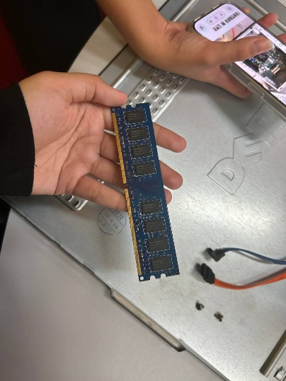
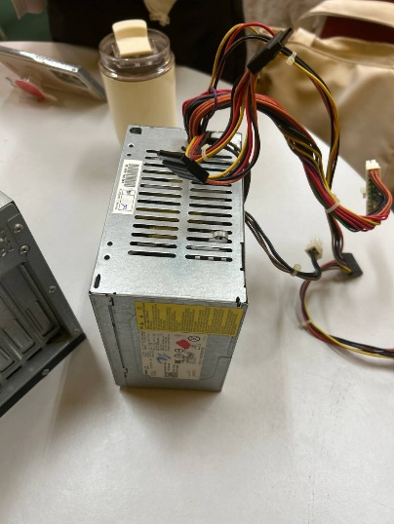
PHOTOS DURING PC ASSEMBLE

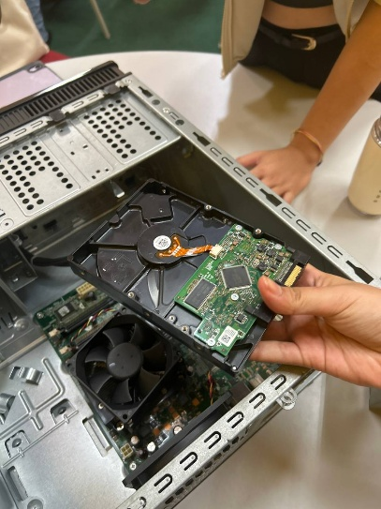
Disconnect Power Supply Unplug RAM
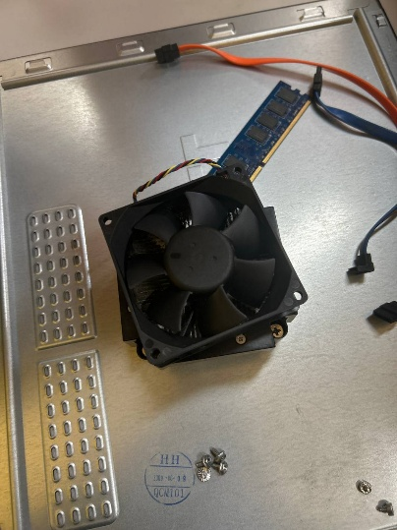

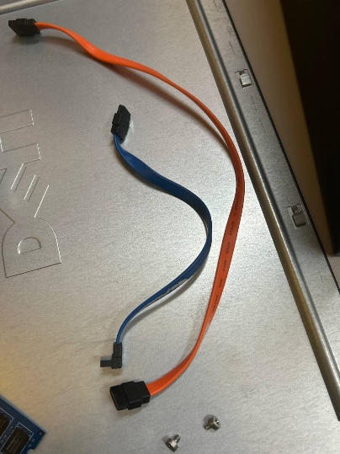
Unplug CPU Fan Remove Hard Disk

CPU Disconnect Cable Orange and Blue
